THE EVALUATION OF SOME DROUGHT INDICES IN SUNFLOWER HYBRIDS IN DRY CONDITIONS

Sevil Sahin¹, Yalcin KAYA¹, Necmi BESER¹

¹ Trakya University, Engineering Faculty, Genetic and Bioengineering Department, Edirne, Turkey
Corresponding author e-mail: yalcinkaya22@gmail.com

ABSTRACT
Sunflower (Helianthus annuus L.) which is the most important oil crops grows mainly drylands in the world. Therefore, environmental conditions mostly influence severely sunflower yields especially in some seasons. In addition to biotic stresses such downy mildew, broomrape parasite, weeds, some other diseases, etc. biotic stress such as drought is the most limiting factor of sunflower production in different parts of the world. Due to global warming, sunflower will affect more these conditions so new developing hybrids need to drought tolerant. The study was conducted to determine their drought tolerance performances and to evaluate their drought indices of some sunflower candidate hybrids in conducted yield trials in Tekirdag and Edirne existing in Trakya Region which is European part of Turkey which has more than 40 % of Turkish sunflower production. Based on the study results, some candidate hybrids had higher drought tolerant indices such as total chlorophyll content, hairiness, dry root weight at stem than control hybrids in the study.

Keywords: Sunflower, Sustainable production, Drought tolerance, Hybrid, Yield traits, Yield performance,

INTRODUCTION
Sunflower grows widely in not only in Turkey both also in Blacksea region countries which has over 60% of the world sunflower planted areas as well as other parts of the world due to higher adaption capability, higher mechanization use, easy marketing (Kaya, 2016, 2020). Hybrids are preferred and used totally in sunflower production both in Turkey and also in other producer countries in the world due to higher yielding, homogeneity and adaption capability (Arslan and Kaya, 2019).
Biotic stresses such as downy mildew and broomrape parasite are the most limiting factors reducing seed and oil yield in sunflower production areas (Sezer et al., 2014, Jocic et al., 2015). However, abiotic stress such as drought, higher temperatures in lower fertility soils especially during grain filling period because as a summer crop sunflower grows mostly in rainfeed areas (Ahmed et al., 2009; Ghaffari et al., 2012; et al., 2012; Pekcan et al., 2012; Andrade et al., 2013). Total chlorophyll measurement which is a novel and easy technique and widely used to measure the plant’s response to drought stresses (Cicek et al., 2019; Arslan et al., 2020). Therefore, these changeable environmental conditions with increasing global warming recently lead that sunflower breeders should consider more and develop drought tolerant hybrids to solve these problems and to produce enough for humanity in the future (Rauf, 2008; Jocic et al., 2015; Kaya and Beser, 2020).
The study was conducted to determine their drought tolerance performances and to evaluate their drought indices of some sunflower candidate hybrids in conducted yield trials in the most planted provinces as Tekirdag and Edirne existing in Trakya Region in 2017.
MATERIAL AND METHOD
The yield trials were conducted in Edirne and Tekirdag location in 2017 to determine yield performances of candidate sunflower hybrids. There were 23 hybrids including 4 controls from commercial hybrids (ITALICA, SY GIBRALTAR, P 64 LL 62, LG 5582) in the market. The experimental design was a Randomized Complete Block Design with four replicates. The four rows plots were 7,50-m long with the 70 x 35 cm plant spacing. Total plot area at planting was 7,5*2,8 as 21 m². The middle two rows were harvested and the border rows were discarded, and plot size was 9.66 m² at harvest. The compose fertilizers (20-20-0, Zn) were applied 200 kg/ha dose at planting. Statistical analysis was performed with JMP statistical program.
Tekirdag location was conducted in Beyazkoy village fields, Saray County and the trials were planted by hand in 15 April 2017. Emergence date of sunflower plants was in 22 April 2017 and left only one plant each as mentioned plant density above. The trials were harvested by hand in 25 August 2017 as middle two rows except one plant at the beginning of the middle rows. Edirne location was conducted in Sarayakpinar village fields and the trials were planted by hand in 28 April 2017. Emergence date of sunflower plants was in 5 May 2017 and the trials were harvested by hand in 5 September 2017. The plant height and head diameter of hybrids were measured from 3 plants at mid rows of the plots in each replication at PM stage. Oil content of the hybrids were determined utilizing Nuclear Magnetic Resonance (NMR) analysis.
Some sunflower hybrids both from classical and IMI types were planted in the pots to measure responses to drought conditions with measuring of dry and wet root weight as well as total chlorophyll content as the most known drought indices in sunflower drought tests (Figure 1, 2 and 3). The ratio of Chlorophyll content of sunflower hybrids was recorded by Portable Florescence Device (HandyPEA, Hansatech Ltd.) at R5-1 vegetative stages (Figure 4). Furthermore, plant height, plant number per area, leaf number per plant, leaf area, anthocyanin existence, head inclination, hairiness at stem, total chlorophyll content, leaf width and leaf length were measured at the yield trials conducted in the field to determine their responses to drought stress.
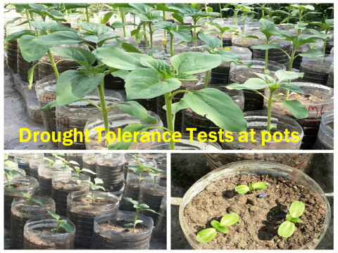
Figure 1. Some classical type sunflower hybrids at the pot study
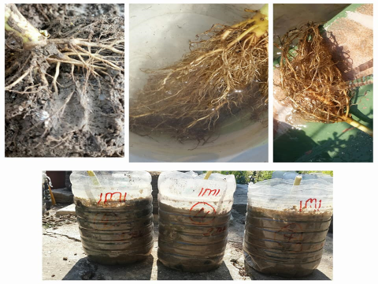
Figure 2. The roots of some sunflower hybrids at the pot study

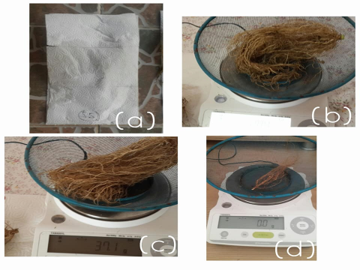
Figure 3. The weighing of the roots of some sunflower hybrids at the pot study

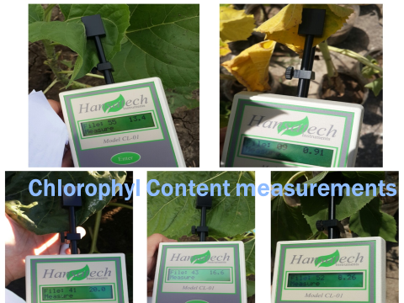
Figure 4. The measuring total chlorophyll content some sunflower hybrids at the field.

RESULTS AND DISCUSSION
Based on the study results, the classical sunflower hybrids exhibited higher performance both for seed and oil yield as SY GIBRALTAR control sunflower hybrid, the candidate hybrid 1628, control hybrid P 64 LL 62 and 9718x RHA64 DMR in Edirne location in the research. On the other hand, in Tekirdag location, the highest seed yield was obtained from 1623 candidate hybrid followed by LG5582 and SY GIBRALTAR sunflower commercial hybrids and the highest oil yield obtained from SY GIBRALTAR, P 64 LL 62 and LG5582 sunflower commercial hybrid. Based on the average results in the study, we could include 1624 candidate hybrid in addition to above ones. In the IMI type hybrids, DT5234 CLP, NS--H-7801, LG5565CL, P-LC108 and IMIO44AXIMI-NI hybrids seems promising ones for seed and oil yield in the study.
Based on study results at the pot study; In IMI herbicide resistant hybrids, Surimi CL hybrid had highest wet and dry root weight as 30,33 g and 6,66 g. LG5565 CL hybrid followed that hybrid and the lowest values were obtained from PUNTASOL CL and SUNFLORA hybrids (Table 1). In classical hybrids, LG5582 had the highest performance had 26,3 g wet and 5,4 g dry root weight respectively. P64LL62 had the lowest value among these hybrids in the study (Figure5 and 6).
The total chlorophyll contents of sunflower hybrids were changed between 7,4 and 15,7 in classical hybrids in Edirne location (Table 2) and between 8,7-15,4 in IMI hybrids in Edirne location (Table 3). The total chlorophyll contents of sunflower hybrids were changed between 6,4 and 12,9 in classical hybrids in Tekirdag location (Table 4) and between 7,8-15,2 in IMI hybrids in Tekirdag location (Table 5). SY Bento, 1644, 1652 and 1654 in classical hybrids; PARAISO 102 CL, 1448 IMI, NS--H-7806, NS--H-7812, NS--H-7854, NS--H-7851, CARRERA CLP, DT5234 CLP and IMIO44A X IMI-NI hybrids in IMI types.

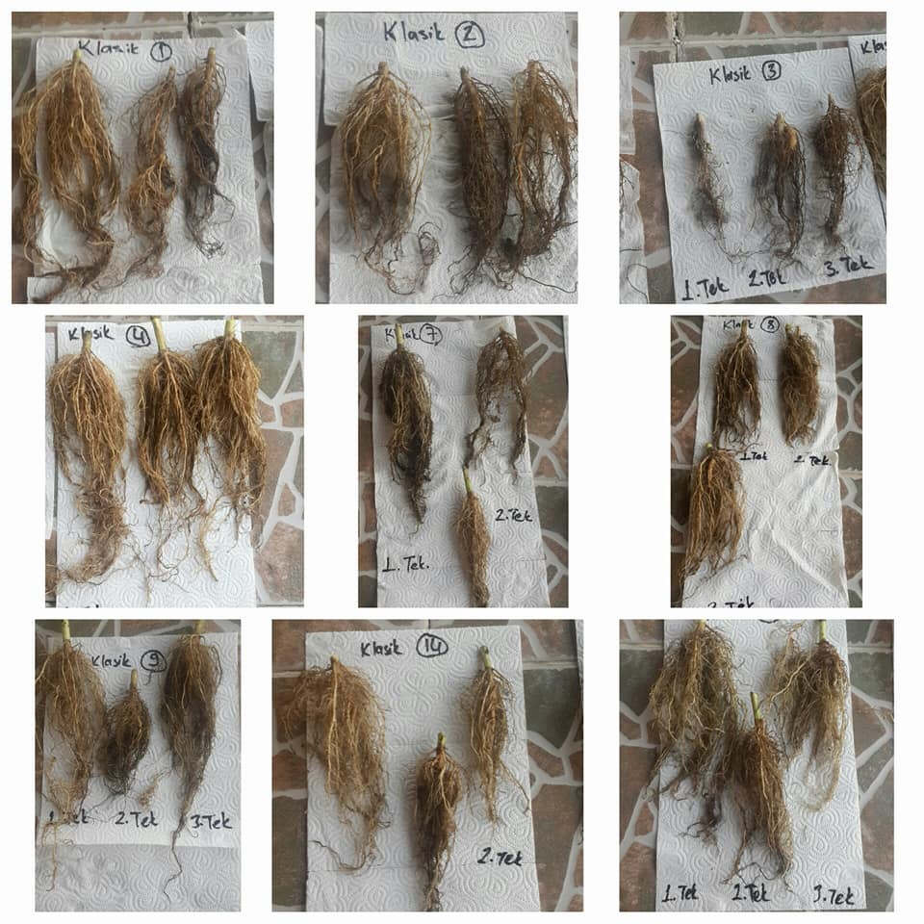

Figure 5. The roots of some classical type sunflower hybrids at the pot study

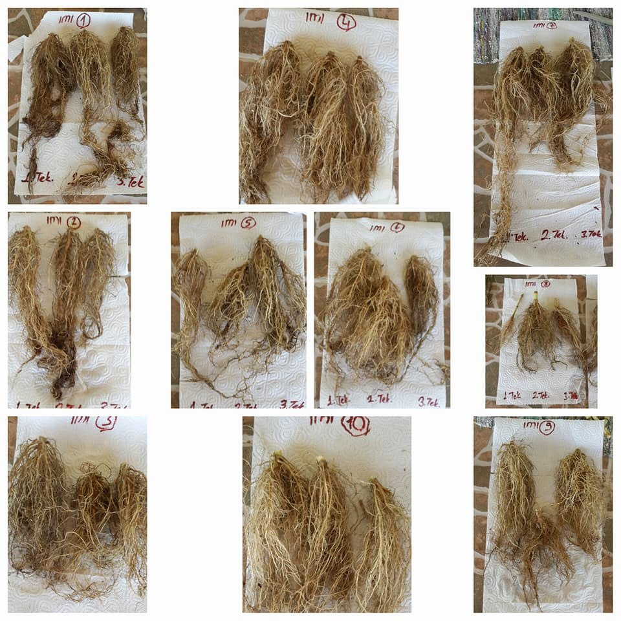

Figure 6. The roots of some IMI type sunflower hybrids at the pot study
Table 1. IMI and Classical sunflower hybrids root weights at the pot trial

IMI hybrids |  |  |  | Classic Type Hybrids
# | IMI Type  Cultivars | Avg  Wet Root Weight (g) | Avg Dry  Root Weight (g) | # | Classic  Type Hybrids | Avg Wet Root Weight (g) | Avg Dry  Root Weight(g)
1 | P-LC108 (C) | 17,53 | 4,96 | 1 | ITALICA (C) | 11,2 | 2,3
2 | SY BENTO (C) | 13,66 | 3,53 | 2 | GIBRALTAR(C) | 8,3 | 2,7
3 | METEOR (C) | 13,8 | 3,36 | 3 | P 64 LL 62 (C) | 5,13 | 1,7
4 | LG5565 CL (C) | 21,16 | 5,66 | 4 | LG 5582 (C) | 26,3 | 5,4
5 | SUNFLORA | 11,33 | 2,43 | 5 | 161 | 13,7 | 3,3
6 | PARAISO102CL | 17,33 | 4,6 | 6 | 163 | 14,3 | 3,2
7 | SURIMI CL | 30,33 | 6,66 | 7 | 1619 | 9 | 1,8
8 | PUNTASOL CL | 9,36 | 3,1 | 8 | 1643 | 10,4 | 2,7
9 | CARRERA CLP | 16,76 | 4,73 | 9 | 1644 | 18,6 | 3,4
10 | DT5234 CLP | 15,83 | 3,23 | 10 | 1563 | 16,8 | 3,0

Table 2. Classical sunflower hybrids total chlorophyll content at the yield trial in Edirne location

1. | 2. | 3. | 4. | 5. | 6. | 7. | 8. | 9. | 10. | 11. | 12.
9,1 | 15,7 | 8,4 | 9,3 | 10,8 | 8,2 | 10,4 | 8,7 | 14 | 11,1 | 10,4 | 10,7
13. | 14. | 15. | 16. | 17. | 18. | 19. | 20. | 21. | 22. | 23.
9,6 | 8,8 | 8,1 | 6,9 | 6,5 | 9,7 | 9,8 | 8,8 | 7,4 | 9,3 | 8,1

Table 3. IMI sunflower hybrids total chlorophyll content at the yield trial in Edirne location

1. | 2. | 3. | 4. | 5. | 6. | 7. | 8. | 9. | 10. | 11. | 12. | 13.
8,06 | 9,6 | 10,2 | 10,6 | 11 | 15,4 | 10,6 | 10,9 | 11,8 | 13 | 11,8 | 14,1 | 13,4
14. | 15. | 16. | 17. | 18. | 19. | 20. | 21. | 22. | 23. | 24. | 25.
12,5 | 14,3 | 15,6 | 13,8 | 14,2 | 11,1 | 9,8 | 9,5 | 13,5 | 9,9 | 8,9 | 8,7

Table 4. Classical sunflower hybrids total chlorophyll content at the yield trial in Tekirdag location

1. | 2. | 3. | 4. | 5. | 6. | 7. | 8. | 9. | 10. | 11. | 12. | 13.
6,4 | 8,3 | 9,4 | 8,5 | 7,1 | 10 | 7,3 | 8,7 | 9,0 | 11,2 | 9,4 | 11,5 | 10,9
14. | 15. | 16. | 17. | 18. | 19. | 20. | 21. | 22. | 23. | 24. | 25.
11,1 | 12,9 | 11,4 | 12,1 | 12,4 | 9,5 | 9,7 | 11,8 | 11,9 | 8,4 | 9,0 | 8,4

Table 5. IMI sunflower hybrids total chlorophyll content at the yield trial in Tekirdag location

1. | 2. | 3. | 4. | 5. | 6. | 7. | 8. | 9. | 10. | 11. | 12.
10,3 | 15,2 | 8,3 | 10,9 | 11,7 | 8,7 | 9,4 | 9,5 | 12,6 | 12,0 | 7,8 | 10,5
13. | 14. | 15. | 16. | 17. | 18. | 19. | 20. | 21. | 22. | 23.
11,8 | 9,1 | 9,6 | 8,8 | 9,4 | 11,4 | 11,01 | 8,8 | 8,5 | 9,7 | 13,7

For drought tolerance in sunflower hybrids, larger leaves ones have more photosynthesis capacity and preferable ones. For larger leaf areas, 1624 1625, LG5565CL SUNFLORA, NS--H-7850, 163, 1619, 1624, 1625, 1434 and 1462 sunflower hybrids seem promising ones (Table 6, 7, 8 and 9). Similarly, hairiness in the stem also preferable ones for drought tolerances. Among hybrids, NS--H-7812 and IMIO44A X IMI-NI in IMI types and 1522 candidate hybrid in classical ones seems having higher values.

Table 6. Some drought indices of sunflower IMI hybrids in Beyazkoy, Tekirdag

# | HYBRIDS | Plant Height (cm) | Plant Number | Leaf Number per plant | Hairiness in the stem (1-9)
1 | P-LC108 | 171 | 82 | 30 | 3
2 | SY BENTO | 178 | 103 | 30 | 3
3 | METEOR | 178 | 98 | 28 | 3
4 | LG5565CL | 174 | 95 | 29 | 3
5 | SUNFLORA | 146 | 42 | 30 | 5
6 | PARAISO 102 CL | 150 | 115 | 26 | 3
7 | SURIMI CL | 190 | 90 | 26 | 1
8 | PUNTASOL CL | 169 | 111 | 28 | 5
9 | CARRERA CLP | 174 | 98 | 29 | 5
10 | DT5234 CLP | 175 | 101 | 29 | 5
11 | 162 IMI | 156 | 94 | 26 | 3
12 | 1448 IMI | 192 | 80 | 29 | 5
13 | NS--H-7800 | 187 | 97 | 30 | 3
14 | NS--H-7801 | 171 | 100 | 32 | 3
15 | NS--H-7806 | 193 | 95 | 31 | 5
16 | NS--H-7812 | 194 | 107 | 31 | 7
17 | NS--H-7854 | 196 | 101 | 31 | 1
18 | NS--H-7851 | 200 | 93 | 28 | 3
19 | NS--H-7850 | 214 | 92 | 29 | 5
20 | NS--H-7856 | 190 | 101 | 29 | 1
21 | NS--H-7863 | 159 | 80 | 28 | 5
22 | NS--H-7859 | 192 | 103 | 28 | 3
23 | IMIO44A X IMI-NI | 172 | 101 | 28 | 7

Table 7. Some drought indices of sunflower IMI hybrids in Beyazkoy, Tekirdag

#. | Hybrids | Anthocyanin Existence (1-9) | Head Inclination  (1-9) | Leaf Shape (1-9) | Branching  (1-5) | Leaf  Width | Leaf  length | Leaf Area
1 | P-LC108 | 1 | 4 | 8 | 5 | 13 | 25 | 325
2 | SY BENTO | 1 | 4 | 8 | - | 11 | 21 | 231
3 | METEOR | 1 | 6 | 8 | - | 14 | 23 | 322
4 | LG5565CL | 1 | 5 | 8 |  | 13 | 26 | 338
5 | SUNFLORA | 1 | 5 | 8 | - | 15 | 27 | 405
6 | PARAISO102CL | 1 | 4 | 8 | - | 11 | 21 | 231
7 | SURIMI CL | 1 | 4 | 8 | - | 10 | 19 | 190
8 | PUNTASOL CL | 1 | 5 | 8 | - | 12 | 20 | 240
9 | CARRERA CLP | 1 | 5 | 8 | - | 10 | 21 | 210
10 | DT5234 CLP | 1 | 6 | 8 | - | 12 | 23 | 276
11 | 162 IMI | 1 | 6 | 8 | 2 | 14 | 24 | 336
12 | 1448 IMI | 7 | 4 | 8 | 4 | 13 | 23 | 299
13 | NS--H-7800 | 1 | 5 | 8 | 5 | 13 | 21 | 273
14 | NS--H-7801 | 1 | 5 | 8 | 5 | 12 | 22 | 264
15 | NS--H-7806 | 1 | 5 | 8 | 1 | 12 | 25 | 300
16 | NS--H-7812 | 7 | 5 | 8 | - | 11 | 23 | 253
17 | NS--H-7854 | 1 | 6 | 8 | - | 13 | 21 | 273
18 | NS--H-7851 | 1 | 7 | 8 | - | 11 | 21 | 231
19 | NS--H-7850 | 1 | 5 | 8 | - | 15 | 24 | 360
20 | NS--H-7856 | 1 | 5 | 9 | - | 11 | 23 | 253
21 | NS--H-7863 | 1 | 5 | 9 | - | 11 | 21 | 231
22 | NS--H-7859 | 1 | 5 | 8 | - | 12 | 23 | 276
23 | IMIO44A X IMI-NI | 1 | 5 | 8 | - | 11 | 22 | 242

Table 8. Some drought indices of sunflower classical hybrids in Beyazkoy, Tekirdag

# | HYBRIDS | Plant Height (cm) | Plant Number | Leaf Number per plant | Hairiness in the stem (1-9) | Anthocyanin existence
1 | ITALICA | 176 | 72 | 27 | 5 | 1
2 | SY GIBRALTAR | 182 | 85 | 29 | 6 | 1
3 | P 64 LL 62 | 184 | 79 | 28 | 5 | 1
4 | LG 5582 | 184 | 85 | 27 | 2 | 1
5 | OS -900 | 178 | 88 | 27 | 4 | 1
6 | 9718xRHA64-DMR | 199 | 93 | 29 | 4 | 1
7 | 161 | 193 | 93 | 27 | 4 | 1
8 | 163 | 205 | 80 | 30 | 6 | 9
9 | 1619 | 169 | 72 | 24 | 4 | 1
10 | 1623 | 199 | 94 | 30 | 3 | 1
11 | 1624 | 185 | 82 | 27 | 6 | 1
12 | 1625 | 199 | 75 | 29 | 5 | 9
13 | 1628 | 192 | 79 | 29 | 4 | 1
14 | 1643 | 195 | 77 | 30 | 4 | 1
15 | 1644 | 202 | 79 | 31 | 6 | 1
16 | 1649 | 201 | 88 | 31 | 6 | 1
17 | 1652 | 205 | 94 | 32 | 6 | 1
18 | 1654 | 219 | 85 | 34 | 6 | 1
19 | 1656 | 185 | 88 | 27 | 6 | 1
20 | 1522 | 189 | 60 | 28 | 8 | 1
21 | 1557 | 184 | 78 | 26 | 6 | 1
22 | 1563 | 169 | 82 | 25 | 5 | 1
23 | 1434 | 204 | 73 | 31 | 4 | 1
24 | 1451 | 191 | 79 | 28 | 5 | 9

Table 9. Some drought indices of sunflower classical hybrids in Beyazkoy, Tekirdag

# | HYBRIDS | Head Inclination (1-9) | Leaf Shape (1-9) | Branching (1-5) | Leaf Width | Leaf length | Leaf Area
1 | ITALICA | 7 | 6 | - | 11 | 20 | 220
2 | SY GIBRALTAR | 5 | 6 | - | 13 | 23 | 299
3 | P 64 LL 62 | 7 | 6 | - | 9 | 20 | 180
4 | LG 5582 | 5 | 6 | - | 13 | 25 | 325
5 | OS -900 | 7 | 6 | - | 10 | 21 | 210
6 | 9718xRHA64-DMR | 7 | 6 | - | 13 | 22 | 286
7 | 161 | 4 | 6 | - | 11 | 21 | 231
8 | 163 | 7 | 6 | - | 13 | 25 | 325
9 | 1619 | 8 | 6 | - | 14 | 27 | 378
10 | 1623 | 8 | 6 | - | 11 | 21 | 231
11 | 1624 | 7 | 6 | - | 14 | 24 | 336
12 | 1625 | 6 | 6 | - | 14 | 24 | 336
13 | 1628 | 5 | 6 | - | 13 | 25 | 325
14 | 1643 | 5 | 6 | - | 12 | 22 | 264
15 | 1644 | 4 | 6 | - | 12 | 20 | 240
16 | 1649 | 6 | 6 | - | 13 | 24 | 312
17 | 1652 | 5 | 6 | - | 12 | 22 | 264
18 | 1654 | 5 | 6 | - | 11 | 22 | 242
19 | 1656 | 4 | 6 | 5 | 11 | 22 | 242
20 | 1522 | 4 | 6 | - | 12 | 25 | 300
21 | 1557 | 5 | 6 | - | 11 | 21 | 231
22 | 1563 | 5 | 6 | - | 10 | 21 | 210
23 | 1434 | 5 | 6 | - | 13 | 27 | 351
24 | 1451 | 3 | 6 | - | 12 | 21 | 252
25 | 1462 | 5 | 6 | - | 14 | 28 | 392

CONCLUSIONS
Based on the study, some hybrids exhibit different performances on measured drought indices. Some of the hybrids seems promising ones for drought tolerance. However, there is no specific and concrete results on evaluated data mainly could be used to determine for drought tolerance connected with seed and oil yield together. Maybe the study was not performed in controlled environments or it could need to conduct longer years or many trials in different locations studies.

REFERENCES
Andrade, A., A. Vigliocco, S. Alemano, A. Llanes G. Abdala. 2013. Comparative Morpho-Biochemical Responses of Sunflower Lines Sensitive and Tolerant to Water Stress. American Journal of Plant Sciences, 4(12C): 156-167.
Ahmed S, Ahmad R, Ashraf MY, Ashraf M, Waraich EA. 2009. Sunflower (Helianthus annuus L.) response to drought stress at germination and seedling growth stages. Pak. J. Bot. 41(2): 647-654.
Arslan, B., Kaya, Y. 2019. Hybrid Sunflower Seed Production and Certification. Seed Science and Seed Technologies Book. 4 Volumes, 839-374. BISAB. Ankara, Turkey. 2154 pages.
Arslan, Ö., A. S. Balkan Nalçaiyi, Ş. Çulha Erdal, V. Pekcan, Y. Kaya, N. Çiçek, Y. Ekmekçi. 2020. Analysis of drought response of sunflower inbred lines by chlorophyll a fluorescence induction kinetics. Photosynthetica. 58 (SI): 163-172.
Ciçek, N., V. Pekcan, Ö. Arslan, Ş. Çulha Erdal, A. S. Balkan Nalçaiyi, A. N. Çil, V Şahin, Y. Kaya, Y. Ekmekçi. 2019. Assessing drought tolerance in field-grown sunflower hybrids by chlorophyll fluorescence kinetics. Brazilian Journal of Botany. 7(25): 1-12.
Ghaffari, M., M. Toorchi, M. Valizadeh, M. R. Shakiba. 2012. Morpho - Physiological Screening of Sunflower Inbred Lines under Drought Stress Condition. Turkish Journal of Field Crops.17(2):185-190.
Jocic, S., D. Miladinovic, Kaya Y. 2015. Breeding and Genetics of Sunflower. N. Dunford, E. M. Force (Ed) Sunflower: Chemistry, Production, Processing, and Utilization. 710 pages. AOCS (American Oil Chemistry Society. 1-26.
Kaya, Y., A. S. Balkan Nalcaiyi, Ş. Çulha Erdal, O. Arslan, N. Cicek, V. Pekcan, G. Evci, M. I. Yilmaz, Y. Ekmekci. 2016. Evaluation of Male Inbred Lines of Sunflower (Helianthus annuus L.) for Resistance to Drought via Chlorophyll Fluorescence. Turkish Journal of Field Crops. 21 (2): 162-173
Kaya, Y. 2020. Sunflower Production in Blacksea Region: The Situation and Problems. International Journal of Innovative Approaches in Agricultural Research, 4(1), 147-155.
Kaya, Y., N. Beşer. 2020. Modern Techniques in Crop Improvement: Conventional and Biotechnological Approach. In: Recent Advances in Plant Science. Editors: F. Vardar, Y. Aydın, A. Altinkut Uncuoglu. Nova Science Publishers, Inc. 137-162.
Pekcan, V., G. Evci, M. I. Yilmaz, A. S. Balkan Nalcaiyi, Ş. Çulha Erdal, N. Cicek, Y. Ekmekci, Kaya, Y. 2015. Drought Tolerance of Some Sunflower Inbred Lines and Effects on Some Yield Traits. Agriculture & Forestry, 61(4): 101-107.
Rauf S. 2008. Breeding sunflower (H. annuus L.) for drought tolerance. Commun in Biometry & Crop Science. 3: 29-44.
Sezer, N., M. Sezgin, G. Evci, V. Pekcan, M. I. Yilmaz, Y. Kaya. 2014. The Determining Yield and Other Yield Trait Performances of Genetically Resistant Sunflower Hybrids against Broomrape in Trakya Region. Proc. of Balkan Agricultural Congress. 08-11 September. Edirne, Turkey. 136.

